

Full name: Samkele Muzila
ID number: 202201545
FINAL YEAR PROJECT
Supervisor: Dr T.T Mapoka

Table of Contents
CHAPTER 1: INTRODUCTION 3
1.1 Project Overview 3
1.2 Problem Statement 3
1.3 Aim and Objectives 4
1.4 Significance of the Study 4
1.5 Scope and Limitations 4
1.6 Project Schedule 5
CHAPTER 2: LITERATURE REVIEW 6
2.1 Overview of Intrusion Detection Systems 6
2.2 Machine Learning in Intrusion Detection 6
2.3 The NSL-KDD Dataset 6
2.4 Related Work and Research Gap 7
CHAPTER 3: REQUIREMENTS ANALYSIS 8
3.1 Functional and Non-Functional Requirements 8
3.2 System Architecture 9
3.3 Development Environment Setup 9
3.3.1 Runtime Environment 9
3.3.2 Python and Node.js Dependencies 10
3.3.3 Project Structure and Dataset 10
3.3.4 Version Control and GitHub 12
3.3.5 Cloud Services 12
CHAPTER 1: INTRODUCTION 4
1.1 Project Overview 4
1.2 Problem Statement 5
1.3 Aim and Objectives 5
1.4 Significance of the Study 5
1.5 Scope and Limitations 6
1.6 Project Schedule 6
CHAPTER 2: LITERATURE REVIEW 7
2.1 Overview of Intrusion Detection Systems 7
2.2 Machine Learning in Intrusion Detection 7
2.3 The NSL-KDD Dataset 7
2.4 Related Work and Research Gap 8
CHAPTER 3: REQUIREMENTS ANALYSIS 9
3.1 Functional and Non-Functional Requirements 9
3.2 System Architecture 10
3.3 Development Environment Setup 10
3.3.1 Runtime Environment 10
3.3.2 Python and Node.js Dependencies 11
3.3.3 Project Structure and Dataset 11
3.3.4 Version Control and GitHub 13
3.3.5 Cloud Services 13
CHAPTER 4: SYSTEM DESIGN 19
4.1 System Architecture 19
4.2 Agent-Based Distributed Monitoring 21
4.3 Machine Learning Pipeline Design 22
4.4 Database Design 24
4.5 API Design 26
4.6 Dashboard Design 27
REFERENCES 28

CHAPTER 1: INTRODUCTION

1.1 Project Overview
The rapid expansion of the internet has fundamentally reshaped global digital infrastructure. According to the ITU (2023), over 5.3 billion people now have internet access, generating unprecedented volumes of network traffic. This growth has simultaneously created an expanded attack surface for malicious actors, with Cisco (2023) estimating cybercrime costs at USD 8 trillion annually.
Intrusion Detection Systems (IDS) serve as a critical defence within cybersecurity infrastructure, monitoring network traffic for malicious activities and generating alerts (Scarfone and Mell, 2007). Traditional signature based IDS match network patterns against known attack databases but cannot detect novel, zero day attacks (Buczak and Guven, 2016). This limitation has motivated the application of Machine Learning (ML) techniques to intrusion detection.
My project proposes the design and evaluation of a Machine Learning Based Network Intrusion Detection System (ML-NIDS). The system will employ four supervised learning algorithms: Random Forest, Decision Tree, K-Nearest Neighbours (KNN) and Gradient Boosting trained on the NSL-KDD benchmark dataset to classify network traffic into five categories: Normal, DoS, Probe, R2L, and U2R. The architecture integrates a Python/Scapy packet capture module, a serverless Node.js backend on Vercel, a Supabase PostgreSQL database with real time subscriptions, a React web dashboard and automated email alerts.

1.2 Problem Statement
Signature based IDS present several critical challenges: inability to detect zero day attacks (Kumar and Sangwan, 2012), high false positive rates causing alert fatigue (Axelsson, 2000), scalability limitations as traffic volumes grow (Garcia-Teodoro et al., 2009) and lack of intuitive real time monitoring dashboards (Shiravi, Shiravi and Ghorbani, 2012). These limitations demonstrate the need for an intelligent IDS that leverages machine learning to improve detection accuracy, reduce false positives, and provide real-time monitoring with automated alerting.

1.3 Aim and Objectives
The aim is to design, implement and evaluate an ML based NIDS capable of real time traffic classification with a web based dashboard and automated alerts. The objectives are:
- To review existing IDS and ML approaches for network security
- To preprocess the NSL-KDD dataset and train four ML algorithms for multiclass classification
- To implement a real time packet capture module using Python and Scapy
- To develop a serverless backend API on Vercel with a Supabase PostgreSQL database
- To build a React web dashboard for real time monitoring and integrate email notifications.

1.4 Significance of the Study
This study provides a comparative analysis of four ML algorithms on NSL-KDD and demonstrates the feasibility of deploying ML-based intrusion detection using cloud native tools.The architecture using Vercel and Supabase shows that sophisticated security monitoring can be achieved without significant capital expenditure making it relevant for organisations in developing economies including Botswana.

1.5 Scope and Limitations
Scope: Training on NSL-KDD (125,973 training, 22,544 test records); classification into 5 categories; four ML algorithms; Python capture module, Node.js API, Supabase database, React dashboard, and email alerts.
Limitations: NSL-KDD is derived from 1999-era traffic; encrypted traffic cannot be inspected; packet capture requires root privileges; class imbalance (R2L ~2%, U2R <1%) may affect minority class accuracy.

1.6 Project Schedule
Table 1.1: Project Schedule
Phase | Activity | Period | Status
1 | Proposal and Literature  Review | Feb 2026 | Completed
2 | Requirements Analysis and Design | Mar 2026 | In Progress
3 | ML Training and  Backend Development | Mar – Apr 2026 | Planned
4 | Frontend and Packet  Capture Development | Apr – May 2026 | Planned
5 | Integration, Testing and  Submission | May – Jun 2026 | Planned

CHAPTER 2: LITERATURE REVIEW

2.1 Overview of Intrusion Detection Systems
An IDS monitors networks or systems for malicious activity and generates alerts (Scarfone and Mell, 2007). First proposed by Anderson (1980) and formalised by Denning (1987), IDS are classified as Network based (NIDS) or Host based (HIDS) by data source (Garcia-Teodoro et al., 2009). By detection method, they are signature based (matching known patterns, unable to detect zero-day attacks) or anomaly based (flagging deviations from normal behaviour, with higher false positive rates) (Chandola, Banerjee and Kumar, 2009). This project implements an anomaly based NIDS using supervised ML.
The evolution of cyber threats has made IDS an indispensable component of modern network security infrastructure. Contemporary attacks range from volumetric Denial of Service (DoS) floods that overwhelm bandwidth, to stealthy Probe scans that map network topology, to Remote-to-Local (R2L) exploits that gain unauthorised access through credential attacks, and User-to-Root (U2R) privilege escalation that converts normal user access into administrative control (Garcia-Teodoro et al., 2009). The diversity and sophistication of these attack vectors necessitate detection systems that can identify patterns across multiple traffic dimensions rather than relying solely on known signatures.

2.2 Machine Learning in Intrusion Detection
ML approaches to IDS include supervised, unsupervised and deep learning methods (Tsai et al., 2009). Ahmad et al. (2021) confirmed that ensemble methods consistently achieve the highest detection rates. This project evaluates four algorithms:
- Decision Tree - Recursively partitions feature space using Gini impurity (Quinlan, 1993). Interpretable with fast inference but prone to overfitting.
- Random Forest - Ensemble of Decision Trees using bagging (Breiman, 2001). Farnaaz and Jabbar (2016) reported 99.67% accuracy on NSL-KDD.
- K-Nearest Neighbours - Classifies by majority vote among k nearest neighbours (Cover and Hart, 1967). High accuracy but slower inference.
- Gradient Boosting - Sequential ensemble correcting predecessor errors (Friedman, 2001).
Tama, Comuzzi and Rhee (2019) found it consistently among the top performers.
In addition to traditional ML algorithms, recent research has explored deep learning approaches for intrusion detection. Vinayakumar et al. (2019) demonstrated that deep neural networks including Convolutional Neural Networks (CNNs) and Long Short-Term Memory (LSTM) networks can achieve competitive accuracy on the NSL-KDD dataset, particularly for detecting minority attack classes such as R2L and U2R. However, deep learning models require significantly larger training datasets and computational resources, and their black-box nature makes interpretation more difficult compared to ensemble methods such as Random Forest and Gradient Boosting. For this reason, this project focuses on interpretable ensemble classifiers that offer a practical balance between accuracy and operational transparency.

2.3 The NSL-KDD Dataset
The NSL-KDD dataset (Tavallaee et al., 2009) improves upon KDD Cup 1999 by removing duplicate records and balancing difficulty levels (McHugh, 2000). It contains 125,973 training and 22,544 test records with 41 features grouped into basic (packet headers), content (payload), time-based (2-second window), and host-based (100 connection window) categories. Attacks are classified as DoS (~36%), Probe (~5%), R2L (~2%), and U2R (<1%), with
Normal traffic at ~57%. It remains the de facto IDS benchmark (Dhanabal and Shanthi, 2015).
The NSL-KDD attack categories reflect four distinct threat classes. DoS attacks (approximately 36 percent of the dataset) aim to exhaust system resources and deny service to legitimate users through techniques such as SYN floods and Smurf attacks. Probe attacks (approximately 5 percent) involve network reconnaissance using tools such as Nmap and port scanners to identify vulnerabilities. R2L attacks (approximately 2 percent) attempt to gain unauthorised remote access through methods such as password guessing and exploitation of network services. U2R attacks (less than 1 percent) seek to escalate privileges from a normal user account to root or administrator level. The significant class imbalance, particularly the scarcity of R2L and U2R samples, presents a challenge for ML classifiers and motivates the use of weighted evaluation metrics such as the weighted F1-score. While more recent datasets such as CICIDS2017 (Sharafaldin, Lashkari and Ghorbani, 2018) offer modern traffic profiles, NSL-KDD remains the most widely used benchmark for comparative evaluation of IDS classifiers.

2.4 Related Work and Research Gap
Ingre and Yadav (2015) achieved 90.3% accuracy with Decision Tree on NSL-KDD. Farnaaz and Jabbar (2016) reported 99.67% with Random Forest. Pervez and Farid (2014) reported 95.2% with SVM. Sommer and Paxson (2010) highlighted the gap between offline classification accuracy and operational deployment. The key research gap is that most studies present ML results without integrating them into a complete deployable system with a real-time dashboard, automated alerting and cloud native deployment. This project addresses this gap directly.
Furthermore, the majority of existing ML-based IDS studies evaluate their models in isolation on a single machine, without considering the operational challenge of monitoring multiple hosts across a network. Snapp et al. (1991) demonstrated the value of distributed intrusion detection with the DIDS project, yet most subsequent ML-based research has not incorporated distributed agent architectures. This project addresses both gaps by combining high-accuracy ML classification with a distributed agent-based deployment model and a cloud-hosted real-time dashboard.

Table 2.1 reveals that existing tools are predominantly signature-based and lack integrated ML capabilities for detecting novel attacks. Furthermore, none of the surveyed tools provide a combined solution of ML-based detection, distributed agent monitoring, cloud-native deployment and a real-time web dashboard with automated email alerts. The ML-NIDS developed in this project addresses these gaps by offering anomaly-based detection through trained ML classifiers, distributed monitoring through lightweight agents, zero-infrastructure cloud deployment via Vercel and Supabase, and an accessible React dashboard with automated SMTP notifications. This combination of capabilities positions the ML-NIDS as a practical, low-cost alternative particularly suited to organisations in developing economies that lack the resources for enterprise-grade commercial IDS solutions.
Feature | Wireshark | Snort | Suricata | OSSEC | Zeek | ML-NIDS (This Project)
Detection Method | Manual analysis | Signature-based | Signature-based | Log analysis | Script-based | ML anomaly-based
Zero-Day Detection | No | No | No | Limited | Limited | Yes (ML classifiers)
Real-Time Dashboard | No | No (needs Splunk) | No (needs ELK) | Basic (Kibana) | No | Yes (React + Realtime)
Distributed Agents | No | No | No | Yes | No | Yes
Email Alerts | No | Limited | Limited | Yes | No | Yes (SMTP)
Cloud Deployment | No | No | No | No | No | Yes (Vercel + Supabase)
Setup Complexity | Low | High | High | High | Very High | Low
Cost | Free | Free | Free | Free | Free | Free (cloud free tier)
Table 2.1: Comparative Analysis of IDS Solutions
Zeek, formerly known as Bro (Paxson, 1999), is a network analysis framework that generates detailed logs of network activity. Unlike signature-based systems, Zeek uses a powerful scripting language that allows analysts to write custom detection logic. However, Zeek requires significant expertise to configure effectively, has no built-in ML capabilities, does not provide a graphical dashboard, and is primarily designed for large enterprise and research networks rather than lightweight distributed deployment.
OSSEC (Bray, Cid and Hay, 2008) is an open-source Host-Based Intrusion Detection System (HIDS) that performs log analysis, file integrity monitoring and rootkit detection. Unlike the previous tools which focus on network traffic, OSSEC monitors individual host activity. It supports a multi-agent architecture where agents report to a central manager. However, OSSEC does not perform network packet analysis, does not use ML for classification, and its dashboard capabilities require additional third-party tools such as Kibana.
Suricata (OISF, 2024) is a high-performance open-source IDS and Intrusion Prevention System (IPS) developed by the Open Information Security Foundation. It improves upon Snort by supporting multi-threaded packet processing, which provides better performance on high-bandwidth networks. Suricata is compatible with Snort rules and adds protocol identification and file extraction capabilities. Despite these improvements, Suricata remains fundamentally signature-based and shares the same limitation of being unable to detect novel attacks without corresponding rules. It also requires dedicated hardware and complex configuration for effective deployment.
Snort (Roesch, 1999) is the most widely deployed open-source NIDS. It operates by matching network packets against a database of predefined rules that describe known attack signatures. Snort is highly effective at detecting known attacks with low false positive rates. However, it cannot detect zero-day attacks that lack existing signatures, requires continuous rule updates to remain effective, has no built-in ML capabilities, and does not provide a native web-based dashboard for real-time monitoring.
Wireshark (Orebaugh, Ramirez and Beale, 2006) is the most widely used network protocol analyser. It captures and displays packets in real time with detailed protocol decoding, allowing analysts to inspect individual packets and reconstruct network conversations. While invaluable for manual network forensics and troubleshooting, Wireshark is not an intrusion detection system. It does not perform automated threat detection, does not generate alerts, and requires a skilled analyst to interpret captured traffic. It is unsuitable for continuous, unattended network monitoring.
To position the ML-NIDS within the landscape of existing tools, this section compares it against five established network security systems: Wireshark, Snort, Suricata, OSSEC and Zeek. Each tool is evaluated on its detection method, ability to identify unknown threats, dashboard capabilities, distributed monitoring support, alerting mechanisms, deployment complexity and cost.

2.5 Comparative Analysis of Existing IDS Solutions

CHAPTER 3: REQUIREMENTS ANALYSIS

3.1 Functional and Non-Functional Requirements
Table 3.1: Functional Requirements
ID | Requirement | Priority
FR-01 | Preprocess NSL-KDD dataset and train 4 ML algorithms | High
FR-02 | Auto-select best model by F1score | High
FR-03 | Capture live packets via Scapy and classify in real-time | High
FR-04 | Store alerts in Supabase PostgreSQL with Realtime enabled | High
FR-05 | Display real-time alerts on React web dashboard with filters | High
FR-06 | Show aggregate statistics with KPI cards and charts | Medium
FR-07 | Send email notification when confidence exceeds 80% | High

Table 3.2: Non-Functional Requirements
ID | Requirement | Target
NFR-01 | ML inference latency | < 5 ms per sample
NFR-02 | Dashboard update latency | < 500 ms
NFR-03 | Detection accuracy on NSL-KDD | ≥ 85%
NFR-04 | False positive rate | < 10%
NFR-05 | Backend and frontend uptime | 99.9%

3.2 System Architecture
The ML-NIDS follows a multi-tier architecture: (1) Data Capture Layer - Python/Scapy extracts 41 features and classifies via the ML model; (2) Application Layer - Node.js serverless API on Vercel with REST endpoints and email service; (3) Data Layer - Supabase PostgreSQL with Realtime enabled; (4) Presentation Layer - React 18 SPA with Recharts and Supabase Realtime subscriptions. Alerts flow from capture through classification, API storage and WebSocket push to the dashboard.

3.3 Development Environment Setup
This section provides evidence that all required tools, dependencies, and cloud services have been configured for the implementation phases.

3.3.1 Runtime Environment
Figure 3.1 confirms the installation of Python 3.14.3, Node.js v24.11.1, npm 11.6.2, pip 25.3 and Git 2.53.0 on the WSL2 development environment.
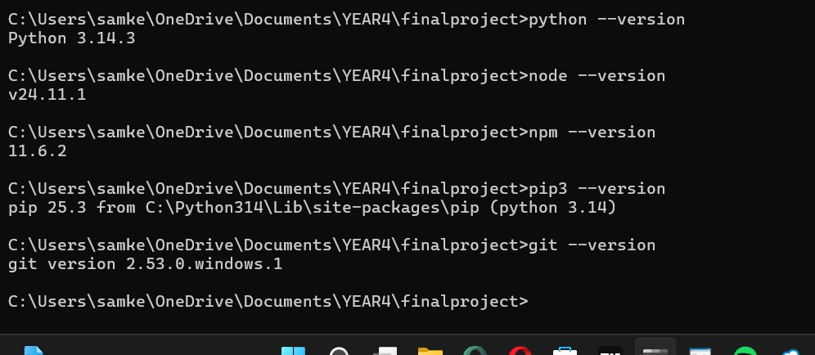
Figure 3.1: Terminal output verifying Python, Node.js, npm, pip, and Git installations.

3.3.2 Python and Node.js Dependencies
ML dependencies (scikit-learn, pandas, numpy, Scapy, matplotlib) were installed via pip. Node.js dependencies were installed via npm for both the backend (@supabase/supabase-js, nodemailer, cors) and frontend (React, Recharts).
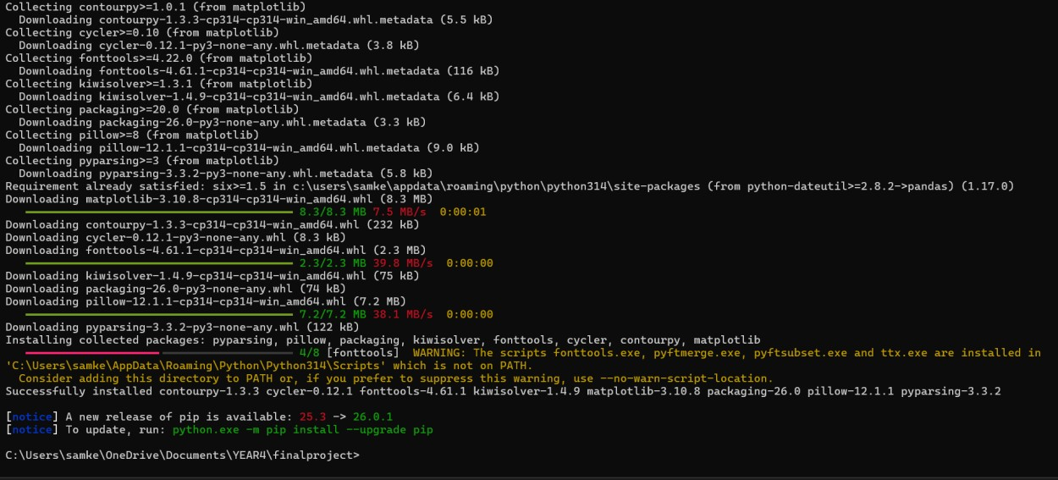
Figure 3.2: Installation of Python ML dependencies

3.3.3 Project Structure and Dataset
The project uses a modular directory structure: backend/, capture/, data/, frontend/, and ml/. The NSL-KDD dataset contains 125,973 training and 22,544 test records.
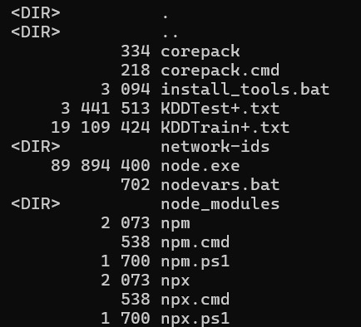
Figure 3.3: Project directory structure
Figure 3.4: shows the data set files downloaded

3.3.4 Version Control and GitHub
The project is hosted on GitHub for source code management. Figure 3.5 shows the repository page.
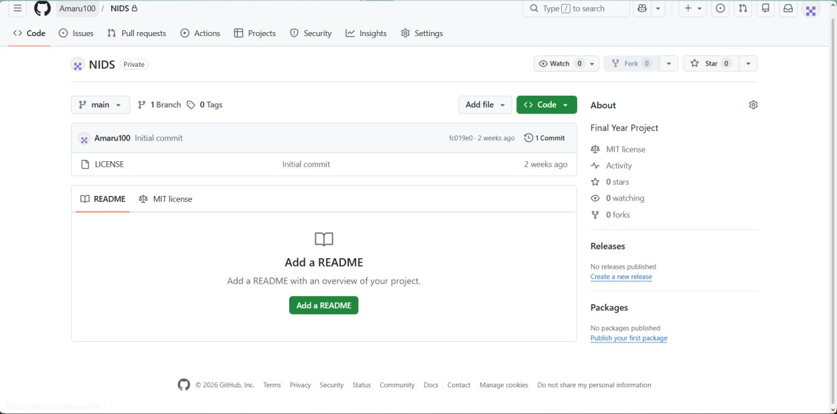
Figure 3.5: GitHub repository for the ML-NIDS project

3.3.5 Cloud Services
Vercel hosts the backend API and frontend dashboard. Supabase provides managed PostgreSQL with Realtime enabled for live dashboard updates.
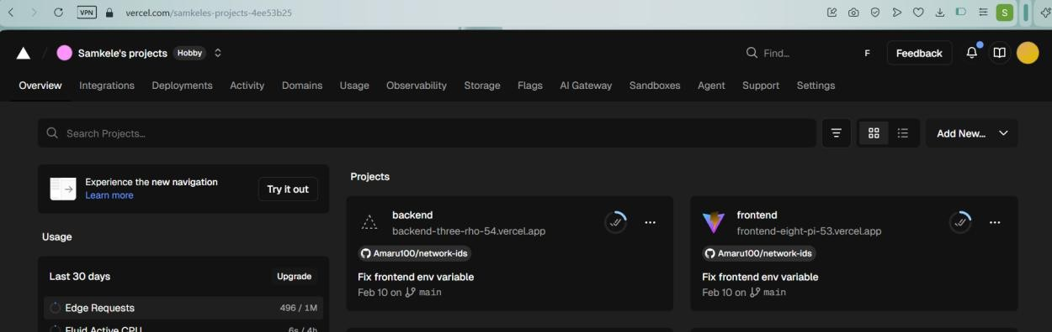
Figure 3.6: Vercel dashboard showing both projects ready to get started
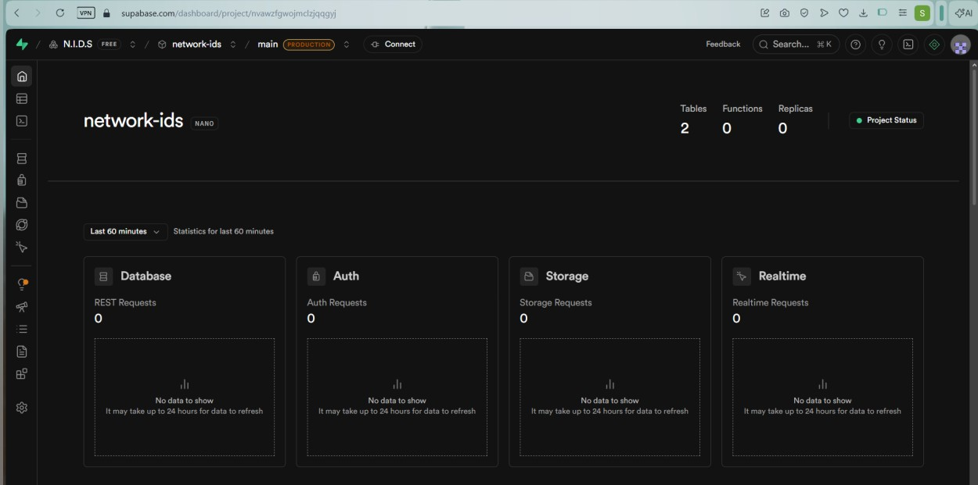
Figure 3.7: Supabase

Gantt Chart representation of the project milestones

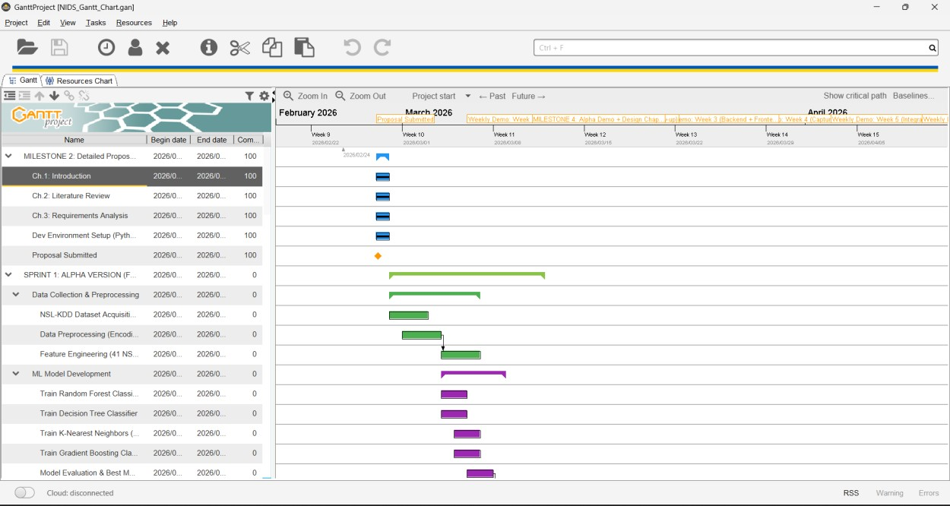

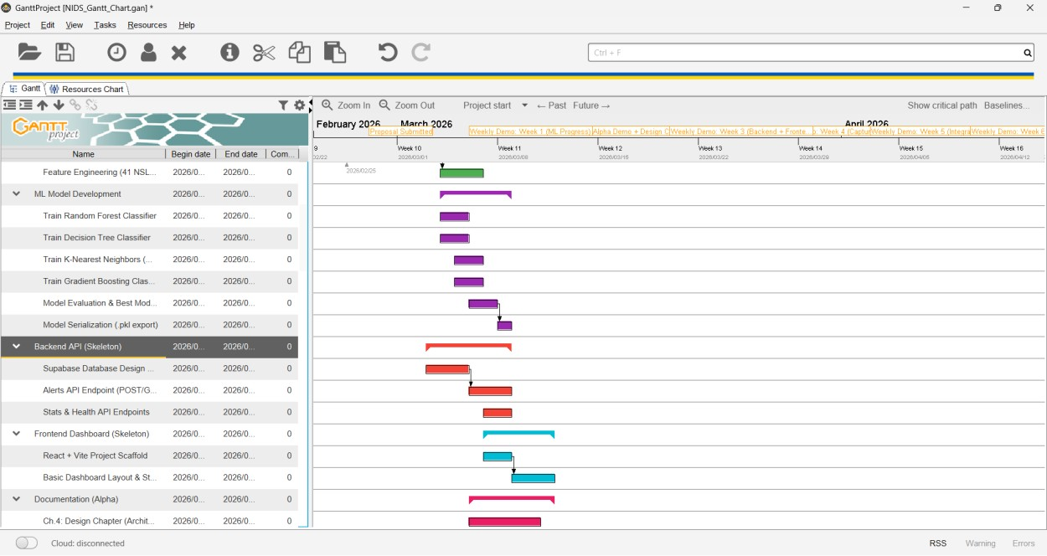

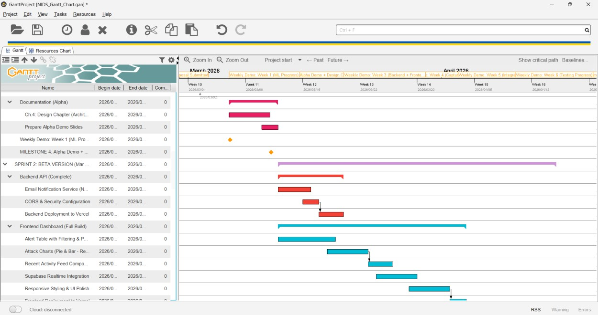

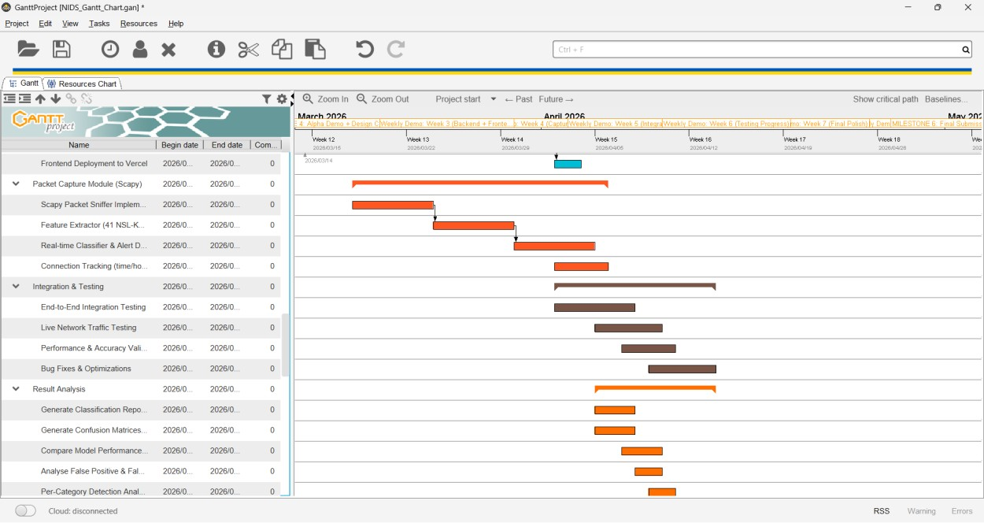

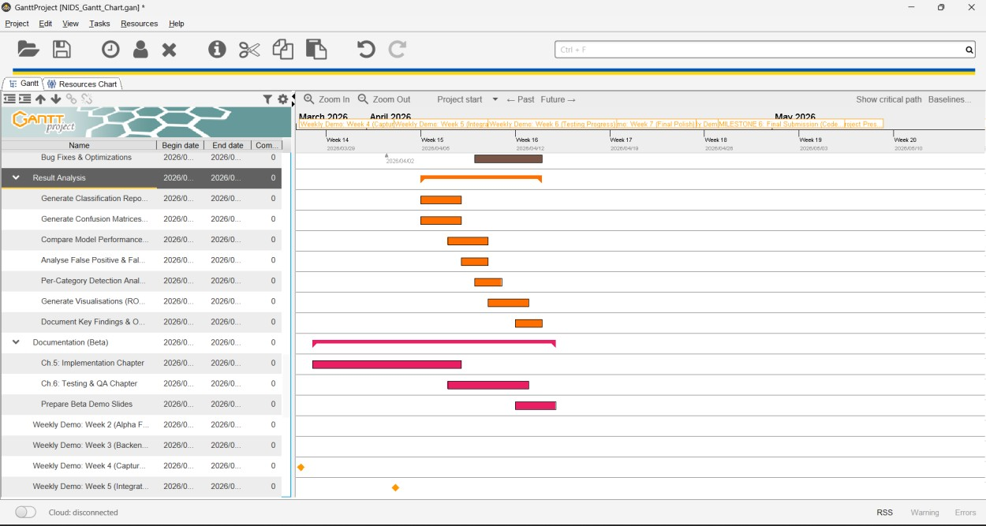

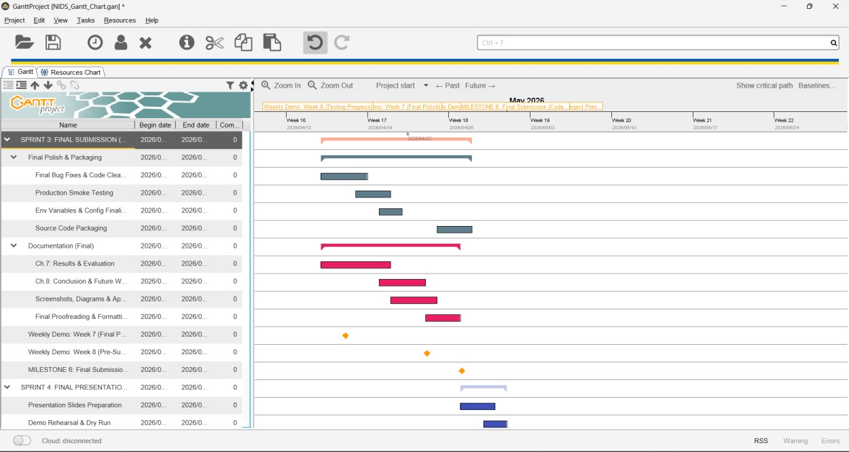
The screenshots above shows the project milestones in Ganttproject . It starts by showing the detailed project proposal and shows the incremental stages of the project as time goes .
I expect to complete the project on the 28th of May 2026.

CHAPTER 4: SYSTEM DESIGN

4.1 System Architecture
The ML-NIDS employs a four-tier event-driven architecture in which data flows upward from raw network packets to the administrator dashboard. Each tier is independently deployable and communicates through well-defined interfaces, promoting modularity, scalability and ease of maintenance. A key architectural decision is the adoption of a distributed agent-based model: lightweight capture agents are installed on individual machines across the network, and each agent independently captures local traffic, classifies it using the trained ML model, and reports detected threats to a centralised cloud backend. This design allows the system to monitor an entire organisation from a single dashboard without requiring a dedicated network tap or span port. The distributed agent approach follows the architectural pattern proposed by Snapp et al. (1991) in the Distributed Intrusion Detection System (DIDS), which demonstrated that correlating alerts from multiple host-based monitors provides superior detection coverage compared to a single network sensor.
The Capture Tier forms the foundation of the system. Each monitored machine runs a Python-based agent that uses the Scapy library to operate in promiscuous mode on the local network interface, intercepting all inbound and outbound IP packets. For every captured packet the agent extracts 41 numerical and categorical features aligned with the NSL-KDD feature schema, including duration, protocol type, service, TCP flag, source and destination byte counts, and both time-window and host-window traffic statistics. A noise filter discards benign background traffic such as multicast and broadcast packets, mDNS, SSDP, LLMNR, DNS queries, and standard web browsing traffic on TCP and UDP ports 80, 443 and 53 (including QUIC/HTTP3). This prevents everyday internet usage from generating false positive alerts, addressing the false positive problem identified by Axelsson (2000) as a primary obstacle to operational IDS deployment. The filtered feature vector is passed through the trained ML model for real-time classification. If the model predicts an attack category (DoS, Probe, R2L or U2R) with a confidence score above the configured threshold, the agent constructs a JSON alert payload containing the classification result, source and destination addresses, port, protocol, confidence score and the agent name, and transmits it to the Application Tier via an HTTPS POST request. Normal traffic is also counted and reported to the backend so that the dashboard can display an accurate normal traffic counter. Each agent additionally sends a heartbeat signal to the backend every 30 seconds, allowing the dashboard to display which machines are currently being monitored and whether each agent is online or offline.
The Data Tier is provided by Supabase, a managed PostgreSQL service with built-in Realtime capabilities. All alerts are stored in the alerts table with indices on timestamp, prediction and confidence to support efficient querying. A separate agents table tracks registered capture agents, their last heartbeat time, and connection metadata. Supabase Realtime broadcasts row-level INSERT events over a persistent WebSocket connection, enabling the dashboard to receive new alerts within milliseconds of database insertion without polling.
The Presentation Tier is a React 18 single-page application built with Vite and deployed on Vercel. It subscribes to the Supabase Realtime channel on mount and updates all visual components reactively as new alerts arrive. The dashboard provides an agent status panel showing all monitored machines with online or offline indicators, KPI summary cards, a tabular alert history with agent name, category and severity columns, and Recharts-based visualisations for attack-class distribution and alert volume trends. Table 4.1 summarises the responsibilities and technologies of each tier.

Table 4.1: System Architecture Tiers
Tier | Technology | Responsibility
Capture | Python 3, Scapy | Packet interception, noise filtering, feature extraction, ML classification, alert and heartbeat dispatch
Application | Node.js, Vercel Serverless | REST API, agent registration, alert ingestion, email notification, statistics aggregation
Data | Supabase PostgreSQL, Realtime | Persistent storage for alerts and agents, real-time event broadcasting, row-level security
Presentation | React 18, Vite, Recharts | Dashboard UI, agent status panel, real-time alert subscriptions, data visualisation

4.1.1 End-to-End Data Flow
The following steps describe the end-to-end data flow from packet capture to dashboard visualisation, illustrating how each component processes and forwards data through the system:
Step 1: The capture agent running on a monitored machine intercepts all IP packets from the local network interface using Scapy in promiscuous mode.
Step 2: The noise filter examines each packet and discards benign network noise including multicast, broadcast, mDNS, SSDP, DNS, and standard web browsing traffic (TCP/UDP ports 80, 443, 53).
Step 4: The feature vector is passed to the Classifier, which applies StandardScaler normalisation and runs the trained ML model (predict_proba) to produce a predicted class (Normal, DoS, Probe, R2L or U2R) and a confidence score.
Step 5: If the prediction is an attack category, the agent constructs a JSON alert payload containing the classification result, source and destination IPs, port, protocol, confidence, severity and agent name, and sends it to the backend via an HTTPS POST request to /api/alerts. Normal traffic is counted and reported separately.
Step 6: The backend serverless function validates the alert payload, inserts it into the Supabase alerts table, and updates aggregate traffic statistics.
Step 7: If the confidence score exceeds 65 percent, the backend triggers the email service which sends an HTML-formatted notification to the administrator via SMTP.
Step 8: Supabase Realtime detects the new row insertion and broadcasts an event over a persistent WebSocket connection to all subscribed dashboard clients.
Step 9: The React dashboard receives the real-time event, prepends the new alert to the local state array, and reactively updates all visual components including the KPI cards, alert table, agent status panel and charts.
Step 10: Concurrently, each agent sends a heartbeat signal to the /api/agents endpoint every 30 seconds, enabling the dashboard to display agent online or offline status in real time.

4.1.2 Architecture Diagrams
Figure 4.1 presents the high-level architecture of the ML-NIDS showing how the four tiers interconnect and how data flows from raw network packets to the administrator dashboard. Multiple capture agents deployed on monitored machines independently capture and classify traffic, then transmit alerts and heartbeat signals over HTTPS to the centralised Vercel backend. The backend persists data to Supabase PostgreSQL, which broadcasts new records over WebSocket to the React dashboard. The email service dispatches SMTP notifications for high-confidence alerts to the configured administrator address.
[INSERT FIGURE 4.1 HERE]
Figure 4.1: High-Level System Architecture Diagram showing the four-tier design, agent distribution and data flow from packet capture to administrator dashboard.

Figure 4.2 presents the low-level component diagram which decomposes each tier into its internal modules and shows the data transformations at each stage. In the Capture Tier, Scapy intercepts raw packets from the network interface and passes them to the noise filter, which discards benign traffic. Packets that pass the filter enter the Feature Extractor module (feature_extractor.py), which converts each raw packet into a 41-element NSL-KDD feature vector using the ConnectionTracker for time-window and host-window statistics. The feature vector is then passed to the Classifier module (classifier.py), which loads the serialised model artifacts (best_model.pkl, scaler.pkl, label_encoder.pkl and feature_names.pkl), applies StandardScaler normalisation, and calls predict_proba to obtain the predicted class and confidence score. If the prediction is an attack category, the Classifier constructs a JSON payload and sends it via HTTPS POST to the Application Tier. In the Application Tier, the alerts.js serverless function validates the payload, inserts it into the Supabase alerts table via the @supabase/supabase-js client, and conditionally invokes emailService.js which uses Nodemailer to dispatch an SMTP notification. The Data Tier receives the INSERT and Supabase Realtime broadcasts it over WebSocket. In the Presentation Tier, the React App component receives the broadcast, updates its state array, and triggers re-renders of the AgentStatus, StatsCards, AlertTable and Chart components.
[INSERT FIGURE 4.2 HERE]
Figure 4.2: Low-Level Component Diagram showing internal modules, data transformations and inter-component communication within each tier.

4.2 Agent-Based Distributed Monitoring
Traditional NIDS architectures rely on a single sensor placed at a network choke point such as a gateway router or a mirrored switch port. While effective for perimeter monitoring, this approach cannot inspect traffic that remains internal to the network, such as lateral movement between compromised hosts (Dreger et al., 2004). The ML-NIDS addresses this limitation through a distributed agent model in which a lightweight Python agent is installed on each machine that requires monitoring. Janakiraman and Vasudevan (2009) demonstrated that multi-agent IDS architectures achieve higher detection rates for insider threats and lateral attacks because each agent has direct visibility into its host machine traffic.
Each agent is a self-contained package consisting of four files: the main capture script (nids_agent.py), a classifier module (classifier.py), a feature extractor module (feature_extractor.py), and a directory containing the serialised ML model artifacts (best_model.pkl, scaler.pkl, label_encoder.pkl and feature_names.pkl). The agent requires Python 3.8 or later, a packet capture driver (Npcap on Windows or libpcap on Linux), and administrator or root privileges to enable promiscuous-mode capture. A setup script automates dependency installation on both Windows and Linux.
On startup the agent identifies the local machine by hostname and IP address, registers itself with the centralised backend by sending an HTTPS POST to the /api/agents endpoint, and begins a background heartbeat thread that repeats this registration every 30 seconds. The backend uses these heartbeats to determine agent liveness: if no heartbeat is received within 60 seconds the agent is marked as offline on the dashboard. This mechanism allows the IT administrator to see at a glance which machines in the organisation are actively being monitored and to investigate any agent that has gone silent. Agent liveness monitoring is a critical operational requirement identified by Bass (2000), who argued that the management plane of an IDS must itself be monitored to ensure comprehensive coverage.
When the agent detects a potential intrusion it includes its own agent name in the alert payload sent to the backend. This name appears in the dashboard alert table and in the email notification, allowing the administrator to immediately identify which specific machine is under attack without having to cross-reference IP addresses manually. Table 4.2 summarises the agent components.
Table 4.2: Agent Package Components
Component | File | Purpose
Capture Script | nids_agent.py | Packet capture, noise filtering, heartbeat thread, classification orchestration
Classifier | classifier.py | Loads ML model, runs inference, sends alerts and normal counts to backend API
Feature Extractor | feature_extractor.py | Converts raw Scapy packets into 41-feature NSL-KDD vectors with traffic statistics
Model Artifacts | model/*.pkl | Serialised best model, scaler, label encoder and feature name list
Setup Script | setup.bat / setup.sh | Automated dependency installation for Windows and Linux

4.3 Machine Learning Pipeline Design
The machine learning pipeline is implemented using scikit-learn and follows a sequential process of preprocessing, training, evaluation and model selection. The pipeline accepts the NSL-KDD training set (125,973 records with 41 features each) as input and produces a serialised model artifact ready for real-time inference on captured network packets.
During preprocessing, the three categorical features (protocol_type, service and flag) are encoded using one-hot encoding via pandas get_dummies, expanding the feature space from 41 raw columns to approximately 122 binary columns. This transformation is necessary because the supervised learning algorithms used in this project require purely numerical input. All numerical features are then normalised using StandardScaler to zero mean and unit variance, which is particularly important for distance-based algorithms such as KNN where features with larger magnitudes would otherwise dominate the distance calculation. The fitted scaler object is serialised alongside the model to ensure identical transformations at inference time.
Four supervised classification algorithms are trained on the preprocessed data, each configured with hyperparameters informed by the literature review. Table 4.3 lists the algorithms, their configurations and the rationale behind each choice.
Table 4.3: Machine Learning Algorithms and Hyperparameters
Algorithm | Key Hyperparameters | Rationale
Decision Tree | max_depth = 10 | Interpretable baseline; depth limit prevents overfitting on noisy features (Quinlan, 1993)
Random Forest | n_estimators = 100 | Bagged ensemble of decision trees that reduces variance and improves generalisation (Breiman, 2001)
K-Nearest Neighbours | k = 5, distance-weighted | Non-parametric classifier effective on well-separated classes; distance weighting reduces sensitivity to outliers (Cover and Hart, 1967)
Gradient Boosting | n_estimators = 150, learning_rate = 0.1 | Sequential boosting corrects residual errors of previous trees; consistently among top IDS performers (Friedman, 2001)
Each model is evaluated on the independent KDDTest+ set (22,544 records) using four metrics: accuracy, precision, recall and weighted F1-score. The weighted F1-score is chosen as the primary selection metric because it balances precision and recall while accounting for class imbalance in the dataset, where R2L comprises only 2 percent and U2R less than 1 percent of samples. The model achieving the highest weighted F1-score is automatically selected as the production classifier and serialised to best_model.pkl using joblib. The corresponding scaler, label encoder and feature name list are saved alongside it to form a complete inference package of four pickle files.
At inference time, the capture agent loads these four artifacts on startup, applies the same preprocessing transformations to each incoming 41-feature vector, and calls predict_proba on the model to obtain both the predicted class and a confidence score. The confidence score is the maximum class probability output by the model and is used downstream to determine alert severity (high above 80 percent, medium between 50 and 80 percent, low below 50 percent) and email notification eligibility (sent when confidence exceeds 65 percent).

4.4 Database Design
The data tier uses Supabase-hosted PostgreSQL with two tables: alerts for storing classified intrusion events and agents for tracking distributed capture agents. This schema was chosen for simplicity and query performance, as the dashboard queries operate primarily on these two entities. Row-Level Security (RLS) is enabled on both tables to enforce access control policies.
The alerts table stores every classified event including both attack detections and metadata for audit purposes.
Table 4.4: Alerts Table Schema
Column | Data Type | Description
id | BIGSERIAL (PK) | Auto-incrementing unique identifier for each alert
timestamp | TIMESTAMPTZ | Time the alert was generated by the capture agent
src_ip | TEXT | Source IP address of the captured packet (attacker)
dst_ip | TEXT | Destination IP address of the captured packet (victim)
src_port | INTEGER | Source port number of the connection
dst_port | INTEGER | Destination port number targeted by the attacker
protocol | VARCHAR(10) | Transport protocol: TCP, UDP or ICMP
prediction | VARCHAR(20) | Model prediction category: Normal, DoS, Probe, R2L or U2R
attack_type | TEXT | Descriptive label of the specific attack type detected
confidence | FLOAT | Model confidence score as a percentage (0 to 100)
severity | VARCHAR(10) | Computed severity level: high, medium or low
agent_name | TEXT | Name of the capture agent that detected the event
model_used | VARCHAR(50) | Name of the ML classifier that produced the prediction
features_json | JSONB | Full 41-feature vector stored for auditability and analysis
created_at | TIMESTAMPTZ | Server-side insertion timestamp (DEFAULT now())

Three database indices are defined to accelerate the most common query patterns: an index on timestamp supports chronological ordering and time range filters on the alert log; an index on prediction enables fast per-class counting for the KPI cards and distribution chart; and an index on confidence supports threshold-based queries such as retrieving only high-confidence alerts for email dispatch.
The agents table tracks all distributed capture agents registered with the system. Each agent upserts its record on every heartbeat, updating the last_heartbeat timestamp. The dashboard queries this table and computes online or offline status based on whether the last heartbeat falls within a 60-second window.
Table 4.5: Agents Table Schema
Column | Data Type | Description
id | BIGSERIAL (PK) | Auto-incrementing unique identifier for each agent
agent_name | TEXT (UNIQUE) | Unique name identifying the agent, typically the machine hostname
hostname | TEXT | Operating system hostname of the machine running the agent
ip_address | TEXT | Local IP address of the monitored machine
os_info | TEXT | Operating system platform information (e.g. Windows-10, Linux-6.1)
last_heartbeat | TIMESTAMPTZ | Timestamp of the most recent heartbeat signal received
registered_at | TIMESTAMPTZ | Timestamp when the agent first registered with the backend

Row-Level Security policies on the alerts table grant INSERT and SELECT privileges to the backend service role, allowing it to write new alerts and read historical data. A DELETE policy is also defined to enable the administrator to clear alerts from the dashboard. The frontend anonymous role is restricted to SELECT only, ensuring that the browser-side client can subscribe to real-time updates but cannot modify or delete records. Similar policies are applied to the agents table. Supabase Realtime is enabled on both tables so that the dashboard receives live updates via WebSocket whenever a new alert is inserted or an agent heartbeat is received.

4.5 API Design
The backend exposes five RESTful endpoints deployed as Vercel serverless functions. Each endpoint is stateless and communicates with the Supabase database using the @supabase/supabase-js client library. All endpoints accept and return JSON payloads and include CORS headers to permit cross-origin requests from the frontend domain.
Table 4.6: REST API Endpoints
Method | Endpoint | Description
GET | /api/health | Returns server status, uptime and current alert count for connectivity monitoring by the dashboard
POST | /api/alerts | Ingests a new alert from a capture agent, validates the payload, persists to the alerts table, updates traffic statistics, and triggers an email notification if confidence exceeds 65%
GET | /api/alerts | Retrieves alert history with optional query filters for category (DoS, Probe, R2L, U2R) and severity (high, medium, low)
GET | /api/stats | Returns aggregate per-class alert counts, severity distribution, and normal traffic count for the dashboard KPI cards and charts
POST | /api/agents | Registers a new agent or updates an existing agent heartbeat; upserts by agent_name with hostname, IP address and OS information
GET | /api/agents | Returns all registered agents with a computed online or offline status based on a 60-second heartbeat timeout
The POST /api/alerts endpoint follows a three-step processing flow. First, the incoming JSON payload is validated to ensure all required fields (src_ip, dst_ip, protocol, prediction, confidence and agent_name) are present. Second, the validated alert is inserted into the Supabase alerts table; upon successful insertion, Supabase Realtime automatically broadcasts the new row to all subscribed dashboard clients. Third, the endpoint evaluates the confidence field: if it exceeds 65 percent, the Nodemailer email service composes and sends an HTML-formatted notification to the configured administrator email address via SMTP. The email service supports both Gmail (using App Passwords) and Microsoft Office 365 (using smtp.office365.com on port 587) as configurable providers. The endpoint returns a 201 status code with the created alert object on success.
The POST /api/agents endpoint uses an upsert operation keyed on agent_name. When an agent sends its first heartbeat the endpoint creates a new row; on subsequent heartbeats it updates the existing row with the current timestamp. The GET /api/agents endpoint retrieves all agents and computes each agent status by comparing the last_heartbeat timestamp against the current time: if the difference is less than 60 seconds the agent is reported as online, otherwise it is reported as offline. This allows the dashboard to display real-time agent connectivity without requiring a persistent connection from each agent.

4.6 Dashboard Design
The dashboard is a React 18 single-page application that provides the network administrator with a real-time overview of all monitored machines and detected threats across the organisation. The interface is divided into four functional regions: an agent status panel, a KPI summary row, a tabular alert log and a visualisation panel.
The agent status panel is displayed at the top of the dashboard and lists every capture agent registered with the system. Each agent entry shows the machine name, IP address, operating system and a colour-coded status indicator: green for online (heartbeat received within the last 60 seconds) and red for offline. The panel polls the agents table every 10 seconds. This gives the IT administrator immediate visibility into which machines are actively being monitored and enables rapid identification of any agent that has stopped reporting, which may itself indicate a security incident or a technical failure.
The KPI summary row sits below the agent panel and displays five cards: Total Alerts (cumulative count of all detected threats), Normal Traffic (count of benign packets classified as normal by the ML model), Active Threats (alerts received in the last 60 minutes), Detection Rate (percentage of traffic classified as malicious) and Backend Status (connectivity indicator derived from the /api/health endpoint). Each card updates reactively as new alerts arrive through the Supabase Realtime subscription.
The alert table is the primary operational component, presenting each alert as a row with columns for Timestamp, Agent Name, Attack Category, Attack Type, Confidence, Severity, Source IP, Destination IP, Port and Protocol. Rows are colour-coded by severity: high-confidence alerts (above 80 percent) appear with a red indicator, medium-confidence alerts (50 to 80 percent) with an orange indicator, and low-confidence alerts (below 50 percent) with a yellow indicator. The inclusion of the Agent Name column allows the administrator to immediately identify which machine detected the threat. The table supports filtering by attack category and severity level through sidebar controls, and a Clear Alerts button enables the administrator to reset the alert history after investigation.
The visualisation panel contains two Recharts components. A pie chart displays the distribution of alerts across the five classification categories (Normal, DoS, Probe, R2L, U2R), providing an at-a-glance view of the prevailing threat composition. A bar chart shows alert counts per category, enabling the administrator to identify which attack types are most prevalent across the monitored network.
All dashboard updates are driven by a Supabase Realtime WebSocket subscription established when the application mounts. The subscription listens for INSERT events on the alerts table and prepends each new alert to the local React state array, triggering a re-render of all dependent components. New alerts also respect any active category or severity filters, so that the administrator view remains consistent during filtering. This push-based architecture eliminates the latency and overhead of periodic polling, ensuring that the administrator observes new threats within milliseconds of detection. Shiravi, Shiravi and Ghorbani (2012) emphasised that effective security visualisation requires real-time data feeds and intuitive visual encodings to reduce the cognitive load on administrators during active incidents.
The dashboard supports real-time filtering by attack category and severity level. New alerts arriving via the Realtime subscription respect active filters, so that the administrator view remains consistent during an investigation. A Clear Alerts function allows the administrator to reset the alert history after incidents have been addressed.
Each model was evaluated on the independent KDDTest+ set (22,544 records) using accuracy, precision, recall and weighted F1-score. The model with the highest weighted F1-score was automatically selected as the production classifier. The selected model, fitted scaler, label encoder and feature name list were serialised to four pickle files (best_model.pkl, scaler.pkl, label_encoder.pkl and feature_names.pkl) using joblib, forming the inference package deployed to each capture agent.

CHAPTER 5: IMPLEMENTATION

5.1 Overview
This chapter describes the implementation of each component of the ML-NIDS system. The implementation follows the four-tier architecture defined in Chapter 4, beginning with the machine learning model training, followed by the backend API, capture agent, frontend dashboard, email notification service and deployment. All source code is maintained in a Git repository hosted on GitHub.

5.2 Machine Learning Model Training and Selection
The ML pipeline was implemented in Python using scikit-learn, pandas and numpy. The NSL-KDD training set (KDDTrain+.csv, 125,973 records) was loaded and preprocessed by one-hot encoding the three categorical features (protocol_type, service and flag) using pandas get_dummies, expanding the feature space to approximately 122 columns. All numerical features were normalised using StandardScaler. The preprocessed data was used to train four classifiers: Decision Tree (max_depth=10), Random Forest (n_estimators=100), K-Nearest Neighbours (k=5, distance-weighted) and Gradient Boosting (n_estimators=150, learning_rate=0.1).
Each model was evaluated on the independent KDDTest+ set (22,544 records) using accuracy, precision, recall and weighted F1-score. The model with the highest weighted F1-score was automatically selected as the production classifier. The selected model, fitted scaler, label encoder and feature name list were serialised to four pickle files (best_model.pkl, scaler.pkl, label_encoder.pkl and feature_names.pkl) using joblib, forming the inference package deployed to each capture agent.
[INSERT TABLE 5.1 HERE: Model Evaluation Results - Accuracy, Precision, Recall, F1 for each algorithm]

5.3 Backend API Implementation
The backend was implemented as Node.js serverless functions deployed on Vercel. Each API endpoint is a standalone JavaScript file in the api/ directory that exports a default request handler function. The @supabase/supabase-js client library provides the database connection, initialised with the Supabase project URL and anonymous key stored as Vercel environment variables.
The alert ingestion endpoint (api/alerts.js) handles both POST and GET requests. On POST, it destructures the incoming JSON body to extract src_ip, dst_ip, protocol, prediction, confidence, severity, attack_type, agent_name and other fields, validates their presence, inserts the record into the Supabase alerts table, calls the updateStats helper to increment per-category counters, and conditionally invokes sendAlertEmail if the confidence exceeds 65 percent. On GET, it queries the alerts table with optional category and severity filters and returns the results ordered by timestamp descending.
The agent registration endpoint (api/agents.js) handles POST requests by upserting agent records keyed on agent_name. Each heartbeat POST includes the hostname, IP address and operating system information. The GET handler returns all agents with a computed online or offline status based on whether the last heartbeat timestamp falls within a 60-second window. The stats endpoint (api/stats.js) aggregates alert counts by category and severity for the dashboard KPI cards. The health endpoint (api/health.js) returns a simple status object for connectivity monitoring.

5.4 Capture Agent Implementation
The capture agent was implemented as a standalone Python package that can be installed on any Windows or Linux machine. The main script (nids_agent.py) initialises the Scapy packet capture engine in promiscuous mode on the default network interface, requiring administrator or root privileges and a packet capture driver (Npcap on Windows or libpcap on Linux).
A critical component of the agent is the noise filter (_is_noise function), which examines each captured packet and discards benign background traffic before it reaches the ML classifier. The filter skips multicast addresses (224.x.x.x to 239.x.x.x), broadcast addresses (x.x.x.255), common discovery protocols on UDP (mDNS port 5353, SSDP port 1900, LLMNR port 5355, NetBIOS ports 137-138), DNS traffic (port 53), and standard web browsing traffic on both TCP and UDP (ports 80, 443 and 53 for HTTP, HTTPS and QUIC/HTTP3). This filtering significantly reduces false positive alerts caused by normal internet usage.
Packets that pass the noise filter are forwarded to the feature extractor module (feature_extractor.py), which converts each raw Scapy packet into a 41-dimensional feature vector aligned with the NSL-KDD schema. The ConnectionTracker class maintains a sliding window of recent connections to compute time-based traffic features (over a 2-second window) and host-based traffic features (over the last 100 connections). The classifier module (classifier.py) loads the four serialised model artifacts on startup, applies StandardScaler normalisation to each incoming feature vector, and calls predict_proba to obtain the predicted class and confidence score. Attack detections are sent to the backend via HTTPS POST, and normal traffic counts are reported separately to keep the dashboard statistics accurate.
A background heartbeat thread runs concurrently with the packet capture loop, sending an HTTPS POST to the /api/agents endpoint every 30 seconds with the agent name, hostname, IP address and operating system information. This enables the dashboard to display real-time agent connectivity status.

5.5 Frontend Dashboard Implementation
The dashboard was implemented as a React 18 single-page application using Vite as the build tool and deployed on Vercel. The main App component establishes a Supabase Realtime WebSocket subscription on mount, listening for INSERT events on the alerts table. When a new alert arrives, it is prepended to the local state array and all dependent components re-render automatically.
The AgentStatus component polls the agents table every 10 seconds and displays each registered agent with a colour-coded online or offline indicator based on the 60-second heartbeat timeout. The StatsCards component renders five KPI cards (Total Alerts, Normal Traffic, Active Threats, Detection Rate and Backend Status). The AlertTable component renders a sortable, filterable table showing all detected threats with columns for Timestamp, Agent Name, Category, Attack Type, Confidence, Severity, Source IP, Destination IP, Port and Protocol. The visualisation panel uses the Recharts library to render a pie chart of attack category distribution and a bar chart of per-category alert counts.
The dashboard supports real-time filtering by attack category and severity level. New alerts arriving via the Realtime subscription respect active filters, so that the administrator view remains consistent during an investigation. A Clear Alerts function allows the administrator to reset the alert history after incidents have been addressed.

5.6 Email Notification Service
The email service (emailService.js) uses Nodemailer to send HTML-formatted alert notifications to the configured administrator email address. The service supports two SMTP providers: Gmail (using App Passwords with 2-Step Verification) and Microsoft Office 365 (using smtp.office365.com on port 587 with STARTTLS). The provider is selected via the EMAIL_PROVIDER environment variable.
Email notifications are triggered when the alert confidence exceeds 65 percent. The email includes a colour-coded HTML template displaying the attack category, specific attack type, confidence score, severity level, source IP (attacker), destination IP (victim), target port, protocol, agent name (identifying the affected machine) and detection timestamp. This provides the administrator with all necessary information to begin incident investigation immediately upon receiving the notification.

5.7 Deployment and Distribution
The backend and frontend are deployed on Vercel via Git integration. Each push to the main branch on GitHub triggers an automatic redeployment. Environment variables for Supabase credentials and email configuration are managed through the Vercel dashboard. The Supabase database was provisioned through the Supabase web console, with tables created via SQL scripts (setup-database.sql for initial setup and migration-beta.sql for schema updates).
The capture agent is distributed as a portable folder containing the Python scripts, model artifacts and setup scripts. A setup.bat script automates dependency installation on Windows (pip install of scapy, pandas, numpy, scikit-learn and requests), and a run-agent.bat script launches the agent with the local computer name as the default agent identifier. Equivalent shell scripts are provided for Linux. The IT administrator can distribute the agent folder to monitored machines via email, USB drive or network share, and end users simply run the setup script once followed by the launcher script.

CHAPTER 6: TESTING AND QUALITY ASSURANCE

6.1 Testing Approach
Testing of the ML-NIDS was conducted using a combination of functional testing, integration testing and live attack simulation. The testing methodology followed a progressive approach: individual components were first verified in isolation, then integrated and tested end-to-end, and finally subjected to realistic attack scenarios across a multi-machine network. The primary objective was to verify that the system can detect real network attacks in real time, display them on the dashboard with correct metadata, and deliver email notifications to the administrator.

6.2 Test Environment
The test environment consisted of two machines connected to the same wireless network via a mobile hotspot. The attacker machine (running WSL2 Linux on Windows) hosted the attack tools including Nmap, hping3 and Hydra. The target machine (Windows) ran the NIDS capture agent. Both machines were assigned IP addresses on the same subnet to ensure direct network reachability. The centralised backend and dashboard were hosted on Vercel and accessible via the internet from both machines.
[INSERT FIGURE 6.1 HERE: Photo of attacker machine and target machine setup before the attack]
Figure 6.1: Test environment showing the attacker machine (left) and target machine (right) connected to the same network.

6.3 Dashboard Baseline
Before commencing attack simulations, the dashboard was verified in its baseline state with no active alerts. The agent status panel confirmed that the target machine agent was registered and online. The KPI cards showed zero total alerts, zero active threats and the backend status indicator confirmed connectivity to the Supabase database.
[INSERT FIGURE 6.2 HERE: Screenshot of the empty dashboard before any attacks]
Figure 6.2: Dashboard in baseline state showing zero alerts and the capture agent registered as online.

6.4 Attack Simulation Testing
Three categories of attacks were simulated from the attacker machine against the target machine to test the detection capabilities of the system. Each attack was executed from the WSL2 terminal while the capture agent was running on the target machine.
Probe Attack (Port Scan): An Nmap SYN scan was launched against the target machine using the command nmap -Pn -sS -p 1-1000 targeting 1000 ports. The -Pn flag was necessary to bypass the ping probe since Windows Firewall blocks ICMP by default. The capture agent detected the rapid succession of SYN packets to different ports and classified the traffic as a Probe (Port Scan) attack with high confidence. The alert appeared on the dashboard within seconds, displaying the correct source IP (attacker), destination IP (target), agent name and classification.
DoS Attack (SYN Flood): A SYN flood was launched using hping3 with the command sudo hping3 -S --flood -p 80 targeting the target machine. This generated a high volume of TCP SYN packets directed at port 80. The capture agent detected the traffic pattern and classified it as a DoS (SYN Flood) attack. Multiple alerts were generated as the flood continued, each with confidence scores indicating the severity of the attack.
R2L Attack (Brute Force): A brute force SSH login attempt was simulated using Hydra with the command hydra -l admin -P wordlist.txt targeting the SSH service on the target machine. This tested the detection of credential-based attacks classified as Remote-to-Local (R2L) intrusions.
[INSERT FIGURE 6.3 HERE: Screenshot of the dashboard during active attacks showing detected alerts]
Figure 6.3: Dashboard during active attack simulation showing detected Probe and DoS alerts from the attacker IP, with agent name and confidence scores.

6.5 Email Notification Testing
The email notification service was tested by triggering alerts with confidence scores exceeding the 65 percent threshold. When a high-confidence attack was detected, the backend successfully dispatched an HTML-formatted email to the configured administrator address via SMTP. The email contained all relevant alert details including the attack category, confidence score, source and destination IPs, target port, protocol and the name of the agent that detected the intrusion.
[INSERT FIGURE 6.4 HERE: Screenshot of the email notification received in the inbox]
Figure 6.4: Email notification received by the administrator showing details of a detected intrusion.

6.6 ML Model Evaluation Results
The trained ML models were evaluated on the KDDTest+ dataset (22,544 records) using standard classification metrics. Table 6.1 presents the evaluation results for each algorithm. The model achieving the highest weighted F1-score was selected as the production classifier and deployed to the capture agents.
[INSERT TABLE 6.1 HERE: Model evaluation results with Accuracy, Precision, Recall, Weighted F1 for each of the 4 algorithms]
Table 6.1: ML Model Evaluation Results on KDDTest+ Dataset

6.7 Known Limitations
During testing, several limitations were identified. First, the NSL-KDD dataset was derived from network traffic captured in 1999, which means the feature distributions may not perfectly represent modern traffic patterns. This occasionally resulted in false positive classifications of benign traffic, which were mitigated through the noise filtering mechanism. Second, encrypted traffic (HTTPS, TLS) cannot be inspected at the packet level, limiting the system to header-based features for encrypted connections. Third, the R2L and U2R attack categories, which comprise less than 3 percent of the training data, may have lower detection accuracy due to class imbalance. Fourth, the capture agent requires administrator privileges and a packet capture driver, which may present deployment challenges in environments with strict access control policies.

6.8 Summary
The testing process confirmed that the ML-NIDS successfully detects network intrusions in real time across a distributed multi-machine environment. Probe attacks were detected through port scan pattern recognition, DoS attacks were identified through traffic volume analysis, and alerts were displayed on the centralised dashboard with correct source, destination and agent metadata. The email notification service delivered timely alerts to the administrator for high-confidence detections. The agent heartbeat mechanism reliably reported agent connectivity status, and the noise filtering mechanism effectively reduced false positives from benign network traffic. These results demonstrate that the system meets the functional and non-functional requirements defined in Chapter 3.

REFERENCES
Ahmad, Z., Shahid Khan, A., Wai Shiang, C., Abdullah, J. and Ahmad, F. (2021) ‘Network intrusion detection system: A systematic study of machine learning and deep learning approaches’, Transactions on Emerging Telecommunications Technologies, 32(1), pp. e4150.
Anderson, J.P. (1980) Computer Security Threat Monitoring and Surveillance. Technical Report. Fort Washington, PA: James P. Anderson Co.
Axelsson, S. (2000) ‘The base-rate fallacy and the difficulty of intrusion detection’, ACM Transactions on Information and System Security, 3(3), pp. 186-205.
Bass, T. (2000) 'Intrusion detection systems and multisensor data fusion', Communications of the ACM, 43(4), pp. 99-105.
Bray, R., Cid, D. and Hay, A. (2008) OSSEC Host-Based Intrusion Detection Guide. Burlington, MA: Syngress.
Breiman, L. (2001) ‘Random Forests’, Machine Learning, 45(1), pp. 5-32.
Buczak, A.L. and Guven, E. (2016) ‘A survey of data mining and machine learning methods for cyber security intrusion detection’, IEEE Communications Surveys and Tutorials, 18(2), pp. 11531176.
Chandola, V., Banerjee, A. and Kumar, V. (2009) ‘Anomaly detection: A survey’, ACM Computing Surveys, 41(3), pp. 1-58.
Cisco (2023) Cisco Annual Internet Report (2018-2023). San Jose, CA: Cisco Systems.
Cover, T.M. and Hart, P.E. (1967) ‘Nearest neighbor pattern classification’, IEEE Transactions on Information Theory, 13(1), pp. 21-27.
Denning, D.E. (1987) ‘An intrusion-detection model’, IEEE Transactions on Software Engineering, SE13(2), pp. 222-232.
Dhanabal, L. and Shanthi, S.P. (2015) ‘A study on NSL-KDD dataset for intrusion detection system’, International Journal of Advanced Research in Computer and Communication Engineering, 4(6), pp. 446–452.
Dreger, H., Feldmann, A., Mai, M., Paxson, V. and Sommer, R. (2004) 'Dynamic application-layer protocol analysis for network intrusion detection', in Proceedings of the 15th USENIX Security Symposium. Vancouver: USENIX, pp. 257-272.
Farnaaz, N. and Jabbar, M.A. (2016) ‘Random Forest modeling for network intrusion detection system’, Procedia Computer Science, 89, pp. 213-217.
Friedman, J.H. (2001) ‘Greedy function approximation: A gradient boosting machine’, Annals of Statistics, 29(5), pp. 1189-1232.
Garcia-Teodoro, P., Diaz-Verdejo, J., Macía-Fernández, G. and Vázquez, E. (2009) ‘Anomaly-based network intrusion detection’, Computers and Security, 28(1-2), pp. 18-28.
Ingre, B. and Yadav, A. (2015) ‘Performance analysis of NSL-KDD dataset using ANN’, in 2015 ICSPCES. Guntur: IEEE, pp. 92-96.
ITU (2023) Global Cybersecurity Index 2022. Geneva: International Telecommunication Union.
Janakiraman, S. and Vasudevan, V. (2009) 'Multi-agent based intrusion detection system for wireless sensor networks', International Journal of Computer Science and Information Security, 6(2), pp. 150-157.
Kumar, V. and Sangwan, O.P. (2012) ‘Signature based intrusion detection system using SNORT’, IJCAIT, 1(3), pp. 35-41.
McHugh, J. (2000) ‘Testing intrusion detection systems’, ACM TISSEC, 3(4), pp. 262-294.
OISF (2024) Suricata: Open Source IDS/IPS/NSM Engine. Available at: https://suricata.io (Accessed: 10 April 2026).
Orebaugh, A., Ramirez, G. and Beale, J. (2006) Wireshark and Ethereal Network Protocol Analyzer Toolkit. Burlington, MA: Syngress.
Paxson, V. (1999) 'Bro: A system for detecting network intruders in real-time', Computer Networks, 31(23-24), pp. 2435-2463.
Pervez, M.S. and Farid, D.M. (2014) ‘Feature selection and intrusion classification in NSL-KDD employing SVMs’, in SKIMA 2014. Dhaka: IEEE, pp. 1-6.
Quinlan, J.R. (1993) C4.5: Programs for Machine Learning. San Mateo, CA: Morgan Kaufmann.
Roesch, M. (1999) 'Snort: Lightweight intrusion detection for networks', in Proceedings of LISA 1999. Seattle: USENIX, pp. 229-238.
Scarfone, K. and Mell, P. (2007) Guide to Intrusion Detection and Prevention Systems (IDPS). NIST SP 800-94.
Sharafaldin, I., Lashkari, A.H. and Ghorbani, A.A. (2018) 'Toward generating a new intrusion detection dataset and intrusion traffic characterization', in ICISSP 2018. Funchal: SciTePress, pp. 108-116.
Shiravi, H., Shiravi, A. and Ghorbani, A.A. (2012) ‘A survey of visualisation systems for network security’, IEEE TVCG, 18(8), pp. 1313–1329.
Snapp, S.R., Brentano, J., Dias, G.V., Goan, T.L., Heberlein, L.T., Ho, C., Levitt, K.N., Mukherjee, B., Smaha, S.E., Grance, T., Teal, D.M. and Mansur, D. (1991) 'DIDS (Distributed Intrusion Detection System): Motivation, architecture, and an early prototype', in Proceedings of the 14th National Computer Security Conference. Washington, DC: NIST, pp. 167-176.
Sommer, R. and Paxson, V. (2010) ‘Outside the closed world: On using ML for network intrusion detection’, in 2010 IEEE S&P. Berkeley: IEEE, pp. 305-316.
Tama, B.A., Comuzzi, M. and Rhee, K.H. (2019) ‘TSE-IDS: A two-stage classifier ensemble for intelligent anomaly-based IDS’, IEEE Access, 7, pp. 94497-94507.
Tavallaee, M., Bagheri, E., Lu, W. and Ghorbani, A.A. (2009) ‘A detailed analysis of the KDD CUP 99 data set’, in 2009 IEEE CISDA. Ottawa: IEEE, pp. 1-6.
Tsai, C.F., Hsu, Y.F., Lin, C.Y. and Lin, W.Y. (2009) ‘Intrusion detection by machine learning: A review’, Expert Systems with Applications, 36(10), pp. 11994-12000.
Vinayakumar, R., Alazab, M., Soman, K.P., Poornachandran, P. and Al-Nemrat, A. (2019) 'Deep learning approach for intelligent intrusion detection system', IEEE Access, 7, pp. 41525-41550.

